The Martin Grade Scenic Highway
Executive Summary

Introduction
The Martin Grade Scenic Highway project is an effort to designate CR 714 (known as the Martin Grade), in Palm City, a Scenic Corridor in accordance with the Florida Scenic Highway Program. The main emphasis of this project is to protect the tree canopy that covers much of the corridor and to help sustain the rural character of the area for generations to come.
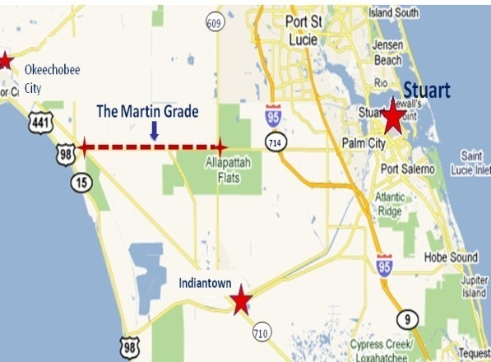

Features of the Corridor
- Extensive tree canopy consisting of 100 year old oaks, palms, pines, and other trees.

- Primary access to 20,000+ acres of conservation land with horse trails, primitive camping, hiking trails, and limited hunting opportunities open to the public.

- A thriving rural community that still engages in cattle ranching, farming, citrus production and equine activities.

- Adjacent to thousands of acres of lands that are targeted for conservation in the future.

- Centered between the unique communities of Stuart, Indiantown, and Okeechobee.

Threats to the Corridor
- Road-widening to accommodate growth and development mainly from St. Lucie County.
- The Regional Long Range Transportation Plan estimates 130,000 new residents in St. Lucie County and 30,000 new residents in Martin County within the next 20 years.
- Destructive maintenance: Poor mowing, ditch cleaning, and tree trimming practices.
- Invasive non-native species: Brazilian Pepper, Old World Climbing Vine, Torpedo Grass, and more.

Environmental Benefits of Scenic Highway Designation
- Helps protect the tree canopy which is the iconographic symbol of rural, western Martin County.
- Creates opportunities for increasing conservation lands and easements targeted by CERP (Comprehensive Everglades Restoration Project) and other conservation and restoration programs.
- Creates opportunities to improve and maintain the natural features of the corridor as well as to remove invasive species.
Economic Benefits of Designation
- Places Martin County on the map (literally) in regards to Scenic Highway and Canopied Road corridors.
- Highlights targeted Western Martin County eco-tourism opportunities while directing visitors to urban communities in the area for lodging and other needs.
- Emphasizes functioning rural businesses – traditional and new.
Cultural Benefits of Designation
- Creates opportunities to teach the history of Martin County and surrounding areas.
- Creates opportunities for the CME to work with government and other agencies to address future transportation needs in a manner that will reduce their impacts on the Martin Grade’s tree canopy, scenic qualities, and rural way of life.

How to Help

Organizations

- The easiest way to show your support is through a formal letter of support. The CPP requires us to show a wide range of support throughout the community.

- Announce your support for the project to your members and direct them as to how they can help protect the Corridor.

- Work with us on awareness and fundraising efforts that mutually benefit our organizational goals.

- We are in need of promotional materials to adequately address our cause to the general public.

Individuals

- Tell your friends about the project and how to contact us through our website and Facebook page.

- Volunteer. We need your help to build public support and to raise money to complete the project. See contact information.

- We are a 501(c)(3) not-for-profit organization. Contributions are welcome and can be made through our website.

- Attend meetings. We encourage all interested parties to attend, show support, and help.

Who We Are

Corridor Advocacy Group (CAG)
The first step in the Designation process is the formation of the CAG which is responsible for the application process and the development of the Corridor Management Plan (CMP). This group is currently made up of interested parties along the corridor. As we progress, we are seeking the participation of a wide range of people throughout the area in order to have a broad base of support. The CAG is also responsible for developing a Community Participation Program (CPP) that aims to involve the entire community in the effort.
Sustaining Community Lands (SCL)

SCL is a Florida non-profit organization that has been designated a 501(c)(3) charitable organization by the IRS. SCL is currently acting as staff for the Corridor Advocacy Group. As such, SCL is involved in research, completing the application, building community support, educational activities, and fundraising efforts. SCL also reports regularly to the CAG on the progress of the application and receives guidance on the direction of the project.

How it Works
Corridor Management Plan (CMP)
The CMP consists of a vision statement along with a set of goals and ways of achieving those goals that is laid out by the CAG. The purpose of the CMP is to direct the Corridor Management Entity (CME) on the initial vision and scope of the corridor.
Corridor Management Entity (CME)
The CME is a community-based group that will be created during the Designation Phase to play a vital role throughout the life of the Corridor. Its members are responsible for updating and achieving the Corridor Vision and keeping the community engaged. This entity will likely consist of some CAG members, along with wildlife experts, planning personnel, business leaders, and politicians. This variety of membership is aimed to ensure that the entire community is involved in the success of the Corridor and for those with specific expertise to assist in implementing the Vision into the future.
Community Participation Program (CPP)
The CPP is a very important step in this process. This program is designed to inform the public of the Martin Grade project, gather support for the Florida Scenic Highway designation, and raise funds to ensure the success and longevity of the Corridor. This is important because designation as a Scenic Highway does not automatically keep the corridor from being widened, which would destroy the canopy. It is only through public involvement that the trees can be saved. Our goal is to build so much support for the Corridor that no politician would dream of voting to bulldoze the trees.

